**Department of Electronic and Telecommunication Engineering**

**University of Moratuwa**

EN-2091 Laboratory Practice and Projects

Automatic Solar Tracker

Electron Envoys – Group 5

JAYAKUMAR W.S. 210236P

JAYATHILAKA C.B.N.L. 210253N

JAYATHILAKA D.E.U. 210254T

KARAVITA K.V.D.T.N. 210272V

**Abstract**

This project focuses on the development and implementation of an automatic solar tracker system with a single-axis control mechanism. The primary objective is to enhance the efficiency of photovoltaic (PV) systems by ensuring optimal alignment with the sun throughout the day. The chosen control strategy for this solar tracker is an analog Proportional-Integral-Derivative (PID) setup. This report commences with the need for more efficient solar energy harvesting systems, an explanation for the use of an analog PID controller, the tuning process, printed circuit board (PCB) design, enclosure design and future improvements.

**Introduction**

With the ever increasing cost of energy and the need for sustainable sources of energy, solar energy is becoming a popular option to satisfy the energy generation needs of people. Solar power can be harnessed to a greater extent especially in countries such a Sri Lanka due to the close proximity of the country to the equator. Solar power can be harnessed in two main methods, namely solar thermal energy which uses the heat generated by the sun, and solar light energy, which uses the light energy emitted by the sun and photovoltaic cells in order to generate energy.

The designed solar tracker is meant for systems using photovoltaic cells. Special cells are combined to form solar panels which can be used to convert the light energy of the sun to generate electricity. One major drawback of this, is that the amount of energy depends on the angle the solar rays make with the panel. In order to overcome this problem, the automatic solar tracker has been proposed. This tracker is capable of tracking the position of the sun and adjusting itself such that the rays of light from the sun make are always perpendicular to the solar panel.

**Functionality Description**

The solar tracker utilizes two light dependent resistors (LDR) connected in series with fixed resistors in order to form a voltage in order to obtain a measure of the intensity of sunlight falling on each. Based on the difference of voltage, it is possible to obtain a measure for the error. This error is buffered and sent to a PID controller. The PID controller has been implemented with the use of Operational Amplifiers (Op-Amps). The output of the PID controller is sent to a Pulse Width Modulation (PWM) generation circuit which generates a PWM signal based on the PID controller output. This PWM signal is sent to a motor driver which controls the motor based on the duty cycle of the PWM signal.

**Block Diagram**

Sunlight Sensing

Sunlight Sensing

Differential Amplifier

PID controller

Summing amplifier

Motor controller

Motor

**Specifications**

* Op-Amps used – Texas Instruments TLV-9352
* Supply Voltage - +9V , -9V
* LDR used – Advanced Photonix NSL-4960
* LDR light resistance - <5kΩ
* LDR dark resistance 1MΩ
* Motor driver used – L293DD
* PCB – 2 layer PCB manufactured by JLCPCB China
* Enclosure – Aluminum frame with plywood surfaces

**Description of individual circuits**

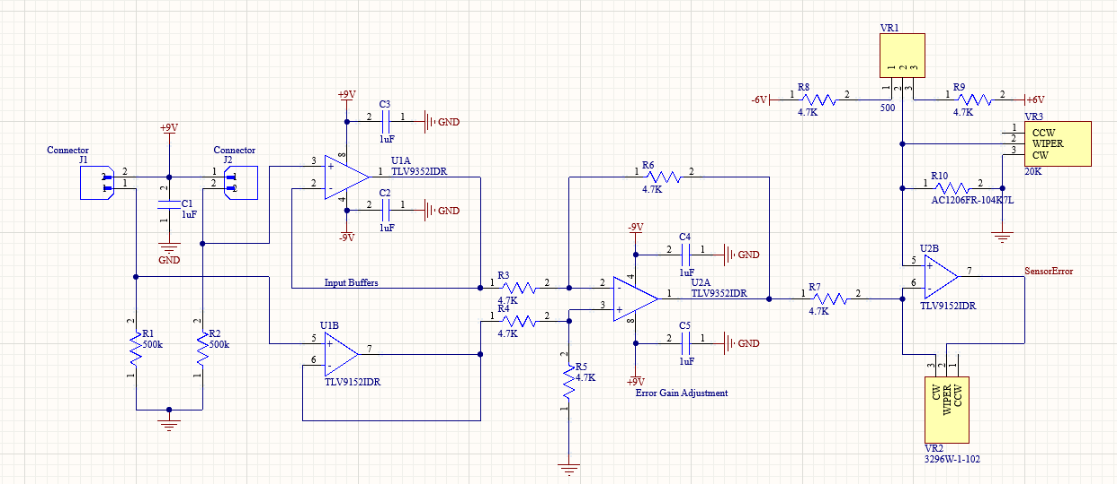**Error Generation**

This is the part of the circuit that is responsible for generating the error signal. The initial stage of this circuit comprises of the voltage divider with the fixed resistors and LDR’s. The LDR’s are connected across the headers shown in the diagram above. Op-Amp U1 functions as a buffer. The buffer keeps the voltage at the output equal to that of the input. The need for the buffer is that any current draw from the voltage divider to other components is prevented due to the large input resistance of the Op-Amp.

This signal is sent to a differential amplifier. A differential amplifier amplifies the difference between the 2 inputs. The equation of the output of the differential amplifier is given as:

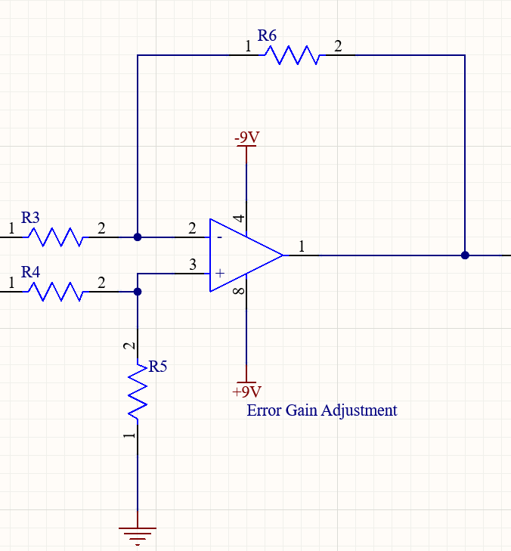

V1

V2

Here, we have used equal resistors and the output is

V2 – V1

The next stage is an error gain adjustment circuit. This is just an inverting amplifier which we use to adjust the gain of the error signal as required.

The output voltage of the inverting amplifier is given as:

Additionally , the circuit features input bias current compensation and input offset voltage compensation. This is to ensure that any errors associated with input bias current and input offset voltage don’t affect the final operation of the solar tracker.

**PID Generation**

A PID controller consists of three separate parts. The proportional part, Integral part and Derivative part. The PID theory is given by:

Where, V is the output, e is the error that is sent as input and Kp, Ki and Kd are constants. The circuit uses Op-Amps in order to implement these individual components of the PID equation.

**P:**

The proportional part of the circuit is implemented as an inverting amplifier. The output voltage is given by:

**I:**

An Op-Amp integrator is used to implement the integrator part of the circuit. The output of the circuit is given as :

This circuit is this able to integrate the error signal. The resistor R22 has been additionally added for better performance in the low frequencies that the solar tracker will be operating in.

**D:**

An op-amp differentiator is used to implement the differentiator. The output voltage is given by:

This circuit is therefore capable of differentiating the error signal. The capacitor C14 has been added for better performance in lower frequencies.

**Gain Adjustment**

After each individual controller, an inverting amplifier has been added to adjust the gain of each controller individually. This is an inverting amplifier and the output voltage can be given as:

This is important when tuning the PID controller and adjusting the values of Kp, Ki and Kd for best performance.

**Weighted Adder**

A weighted adder is used to add the outputs of the P, I and D controllers.

The output of this is given by:

**PWM Generation**

The error signal is used to generate a PWM signal of required duty cycle in order to control the motors.

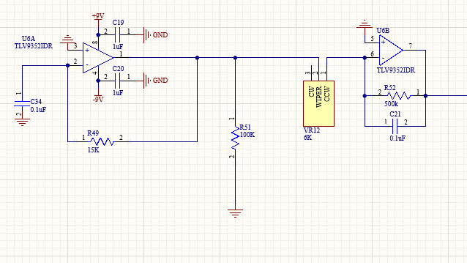The first stage in this is the generation of a square wave and it’s differentiation in order to produce a triangular wave.

Next, the produced triangle wave is rectified. Two op-amps are used for this purpose. Parallelly, another circuit also rectifies the PID output. The following circuit is capable of rectifying the signal. The advantage of this circuit over a full bridge rectifier is that there isn’t a voltage drop due to forward biased PN junctions in the diodes.

Next, the rectified triangle wave and rectified PID output signal are sent through a comparator. The output is a PWM signal whose magnitude changes according to the magnitude of the PID signal.

An op-amp operating in the open loop configuration can be used as a comparator.

The final stage of the motor control is to determine the direction in which the motor should spin. For this, the PID output is compared with 0V with two comparators. Based on whether PID output is positive or negative, one of the two op-amps shown will output a positive voltage and the other will output a negative voltage. Whichever outputs the positive voltage would saturate the transistor and hence effectively ground the input to which the collector is connected to. The other transistor would be cut-off and hence the output signal from the PWM generation would be sent to the relevant input of the motor driver and hence the direction of the motor can be controlled.

**PCB Design**

A 2 layer PCB has been designed to accommodate the circuit. The following are images of the PCB design.

Top Layer

Bottom Layer

3D Layout

Components used on the PCB are 1206 SMD components wherever possible. The op-amps have the 8-SOIC package. Potentiometers and JST headers used are through hole type packages.

The PCB is extremely compact measuring just 123 mm in length and 82 mm in width. Most of the routing is done on the top layer and all the other touting is done on the bottom layer. The top and bottom layers have been both used as a common ground reference plane.

The PCB was manufactured by JLCPCB in China.

**Enclosure**



The enclosure is made from 2 materials. The enclosure cover is made from plywood and the frame is made out of Aluminum. Plywood was selected due to it’s light weight and aluminum was selected due to it’s durability for this application. The 2 LDR’s will be placed at the top and bottom of the panel holder in order to space them apart as much as possible to be able to obtain an error signal. Additionally, the LDR’s are surrounded by a cover to make sure most of the sunlight hitting it would be perpendicular to the holder.

The size of the bottom base is 35 cm x 35 cm x 4cm. This is made using Aluminum box bars. The height of the side supports is 17 cm. The panel holder is 30 cm x 32 cm in size. It has been designed to support 4 solar panels each of size 12.5 cm x 13.5 cm which are commonly available in the market.

**Task Allocation**

* Jayakumar W.S. – 210236P- Enclosure design
* Jayathilaka C.B.N.L. – 210253N- Circuit design
* Jayathilaka D.E.U. – 210254T- Circuit simulation and testing
* Karavita K.V.D.T.N. – 2107272V- Circuit simulation and testing

**Future Improvements**

The solar tracker uses a separate dc power supply to power all the components. Therefore, the first improvement would be to run the solar panel using the solar power it generates. This would reduce the number of wires needed to travel to and from the device and would enable the tracker to function when external power is not available.

Another improvement would be to design mounts that would make it easier to mount the tracker on roofs. Our current design only has a stand and since this device would be placed on rooftops, designing mounts would beneficial.

**Conclusion**

The designed solar tracker is extremely beneficial in today’s world given the increasing cost of energy and the abundance of solar power. It would greatly improve the efficiency of solar power generation in the future.

**Acknowledgements**

First and foremost we would like to thank our supervisors who guided us as we undertook this project. Their expertise, guidance and insights proved invaluable to us along the way. We would also like to thank our lecturers and instructors who’s vast knowledge was of utmost importance to us. We would also like to thank our colleagues who undertook the automatic solar tracker project and other projects for their support and assistance.